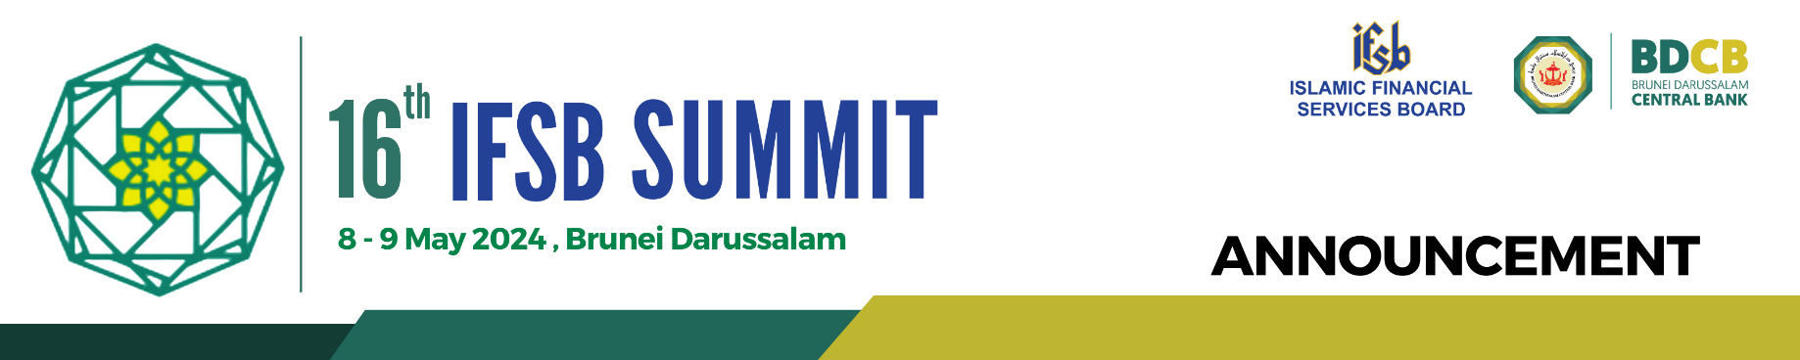

Mark your calendar!

We are thrilled to announce the 16th IFSB Summit, scheduled to take place on 8 – 9 May 2024 in the beautiful setting of Bandar Seri Begawan, Brunei Darussalam.

With the theme "Islamic Finance and Financial Stability in an Evolving Environment: Navigating Emerging Risks", the Summit aims to bring together key policy makers and stakeholders to deliberate on issues pertinent to the resilience of the IFSI and the policy implications of new risks. The summit will also consider opportunities and benefits of embracing change and innovation in the Islamic finance industry and how they can be harnessed to bolster sustainable, inclusive, stable and resilient growth of the IFSI.

What Awaits You:
- Engage yourself in high-level discussions on the IFSI's resilience and stability
- Delve into the policy implications of emerging risks in the Islamic finance sector
- Navigate through the global challenges, from macroeconomic shifts to technological transformation and climate-related financial risks
- Assess the effectiveness of regulatory frameworks in addressing new industry challenges
- Discover opportunities for growth and innovation within the Islamic finance sector

The 16th IFSB Summit will be held at the Empire Brunei Hotel. This Summit is organised by the Islamic Financial Services Board (IFSB) and hosted by the Brunei Darussalam Central Bank (BDCB). The IFSB and BDCB look forward to the participation of the members of the IFSB, Economic/Financial policymakers and senior management from Ministries of Finance/Economic Development, Regulatory and Supervisory Authorities (RSAs), International Organisations (IOs), Institutions Offering Islamic Financial services (IIFS), Multilateral Development Banks, Academia, Market Players, and other relevant stakeholders.

Stay tuned for more updates and the opening of registration.

