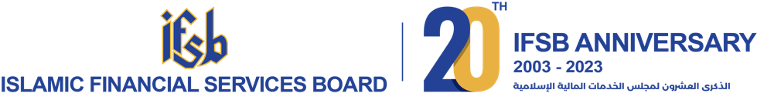

PRESS
RELEASE

IFSB Media Contact:
Nor Atiqah/ Ammar Khairi
Tel: +603 9195 1420
Email: nor.atiqah@ifsb.org/ ifsb_sec@ifsb.org

Saudi Central Bank to Host the 43rd IFSB Council Meeting in Jeddah
Kuala Lumpur, 26 December 2023 - The Saudi Central Bank (SAMA) will be hosting the 43rd Islamic Financial Services Board (IFSB) Council Meeting, scheduled to take place on the 29th of December 2023 in Jeddah, Saudi Arabia.
Under the esteemed leadership of H.E. Ayman Al Sayari, Governor of SAMA and Chairman of the IFSB for 2023, the upcoming meeting marks a pivotal moment that will shape the trajectory of the IFSB in 2024 and beyond, influencing its strategic direction and policies. The Council convenes twice a year and is a platform where central bank Governors and Deputy Governors, heads of regulatory and supervisory authorities, and distinguished representatives from among the Council and Full members of the IFSB gather to deliberate on crucial matters, including pressing issues facing the Islamic finance industry.
Dr. Bello Lawal Danbatta, the Secretary-General of the IFSB expressed the Secretariat’s optimism and gratitude, “We eagerly anticipate the positive outcomes from this meeting that will significantly contribute to enhancing governance and results within the IFSB. Our heartfelt appreciation to H.E. Ayman Al Sayari for his admirable stewardship as the Chairman of the Council for 2023, and to the Saudi Central Bank for their tremendous support and remarkable dedication that resulted in the wonderful collaborations we have achieved together this year.” He further adds, “The steadfast support and participation of the Council and Full members of the IFSB in this meeting will be instrumental for us to advance our shared mission of promoting the stability and resilience of the Islamic financial services sector.”
Set at the Ritz-Carlton Hotel in Jeddah, the 43rd IFSB Council Meeting is poised to not only strengthen the bonds among member countries but also to reinforce the Islamic finance sector's role in supporting sustainable economic growth and financial inclusion on a global scale.
For more information on the IFSB, visit www.ifsb.org.
----------------------------------------------------------- End of release -------------------------------------------------------

About the Islamic Financial Services Board (IFSB)
The IFSB is an international standard-setting organisation that promotes and enhances the soundness and stability of the Islamic financial services industry by issuing global prudential standards and guiding principles for the industry, broadly defined to include banking, capital markets and insurance sectors. The IFSB also conducts research and coordinates initiatives on industry-related issues, as well as organises roundtables, seminars and conferences for regulators and industry stakeholders. Towards this end, the IFSB works closely with relevant international, regional and national organisations, research/educational institutions and market players.
The members of the IFSB comprise regulatory and supervisory authorities, international inter-governmental organisations and market players, professional firms and industry associations.
For more information about the IFSB, please visit www.ifsb.org

